Анализ сайта для создания парсинга
Url сайта анализа: https://ice-palace.com/
Скорость загрузки сайта
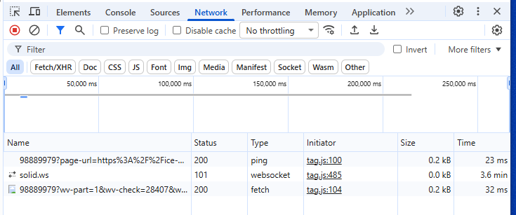
URL Ссылка на афишу https://ice-palace.com/afisha-spb
Контейнер афиш:
<ul class="t853__container t-container_flex t-card__container
t853__container_mobile-grid " role="list" data-blocks-per-row="3"> <li class="t853__col t-col t-col_4 t-align_center t-item
t853__col_mobile-grid "> <div class="t-card__col
" style="cursor: pointer;"> <div class="t853__content"> <div class="t853__imgwrapper
" style="padding-bottom:61.111111111111%;" bgimgfield="li_img__1646935827275"> <div class="t853__bgimg t-bgimg loaded" data-original="https://static.tildacdn.com/tild3838-6361-4539-a663-373361386264/d3c6cb7a08dde477bfed.jpg" style="background-image: url(&quot;https://optim.tildacdn.com/tild3838-6361-4539-a663-373361386264/-/cover/360x220/center/center/-/format/webp/d3c6cb7a08dde477bfed.jpg.webp&quot;);" role="img" aria-label="Симфонические рок-хиты." itemscope="" itemtype="http://schema.org/ImageObject"> <meta itemprop="image" content="https://static.tildacdn.com/tild3838-6361-4539-a663-373361386264/d3c6cb7a08dde477bfed.jpg"> <meta itemprop="caption" content="Симфонические рок-хиты."> </div> </div> <div class="t853__textwrapper"> <div class="t-card__descr t-descr t-descr_sm" field="li_descr__1646935827275"> <div style="font-size: 22px;" data-customstyle="yes"><strong>Симфонические рок-хиты.</strong></div> </div> </div> </div> <div class="t-card__btn-wrapper"> <a class="t-btn t-btnflex t-btnflex_type_button t-btnflex_sm t-card__btn t-card__link" href="https://teatr-art.ru/ledovii" id="cardbtn1_824337954" data-lid="1646935827275"> <span class="t-btnflex__text">Подробнее</span> <style>#rec824337954 .t-btnflex.t-btnflex_type_button {color:#120c0c;border-style:solid !important;border-color:#ff6600 !important;--border-width:2px;border-radius:30px;box-shadow:0px 0px 20px rgba(0,0,0,0.4) !important;font-family:Arial;transition-duration:0.2s;transition-property:background-color,color,border-color,box-shadow,opacity,transform;transition-timing-function:ease-in-out;}@media (hover:hover) {#rec824337954 .t-btnflex.t-btnflex_type_button:not(.t-animate_no-hover):hover {background-color:#ff6600 !important;}#rec824337954 .t-btnflex.t-btnflex_type_button:not(.t-animate_no-hover):focus-visible {background-color:#ff6600 !important;}}</style> </a> </div> </div> </li> <li class="t853__col t-col t-col_4 t-align_center t-item
t853__col_mobile-grid "> <div class="t-card__col
" style="cursor: pointer;"> <div class="t853__content"> <div class="t853__imgwrapper
" style="padding-bottom:61.111111111111%;" bgimgfield="li_img__1644843924470"> <div class="t853__bgimg t-bgimg loaded" data-original="https://static.tildacdn.com/tild6665-6565-4439-a639-653633643161/s380x220.jpg" style="background-image: url(&quot;https://optim.tildacdn.com/tild6665-6565-4439-a639-653633643161/-/cover/360x220/center/center/-/format/webp/s380x220.jpg.webp&quot;);" role="img" aria-label="Панк-сказка «Король и Шут»" itemscope="" itemtype="http://schema.org/ImageObject"> <meta itemprop="image" content="https://static.tildacdn.com/tild6665-6565-4439-a639-653633643161/s380x220.jpg"> <meta itemprop="caption" content="Панк-сказка «Король и Шут»"> </div> </div> <div class="t853__textwrapper"> <div class="t-card__descr t-descr t-descr_sm" field="li_descr__1644843924470"> <div style="font-size: 22px;" data-customstyle="yes"><strong>Панк-сказка «Король и Шут»</strong></div> </div> </div> </div> <div class="t-card__btn-wrapper"> <a class="t-btn t-btnflex t-btnflex_type_button t-btnflex_sm t-card__btn t-card__link" href="https://teatr-art.ru/ledovii" id="cardbtn2_824337954" data-lid="1644843924470"> <span class="t-btnflex__text">Подробнее</span> <style>#rec824337954 .t-btnflex.t-btnflex_type_button {color:#120c0c;border-style:solid !important;border-color:#ff6600 !important;--border-width:2px;border-radius:30px;box-shadow:0px 0px 20px rgba(0,0,0,0.4) !important;font-family:Arial;transition-duration:0.2s;transition-property:background-color,color,border-color,box-shadow,opacity,transform;transition-timing-function:ease-in-out;}@media (hover:hover) {#rec824337954 .t-btnflex.t-btnflex_type_button:not(.t-animate_no-hover):hover {background-color:#ff6600 !important;}#rec824337954 .t-btnflex.t-btnflex_type_button:not(.t-animate_no-hover):focus-visible {background-color:#ff6600 !important;}}</style> </a> </div> </div> </li> <li class="t853__col t-col t-col_4 t-align_center t-item
t853__col_mobile-grid "> <div class="t-card__col
" style="cursor: pointer;"> <div class="t853__content"> <div class="t853__imgwrapper
" style="padding-bottom:61.111111111111%;" bgimgfield="li_img__1531230022700"> <div class="t853__bgimg t-bgimg loaded" data-original="https://static.tildacdn.com/tild3863-6436-4465-b134-333061323037/6d968c9fb8027308963d.jpg" style="background-image: url(&quot;https://optim.tildacdn.com/tild3863-6436-4465-b134-333061323037/-/cover/360x220/center/center/-/format/webp/6d968c9fb8027308963d.jpg.webp&quot;);" role="img" aria-label="Cinema Medley: Hans" itemscope="" itemtype="http://schema.org/ImageObject"> <meta itemprop="image" content="https://static.tildacdn.com/tild3863-6436-4465-b134-333061323037/6d968c9fb8027308963d.jpg"> <meta itemprop="caption" content="Cinema Medley: Hans"> </div> </div> <div class="t853__textwrapper"> <div class="t-card__descr t-descr t-descr_sm" field="li_descr__1531230022700"> <strong>Cinema Medley: Hans</strong> </div> </div> </div> <div class="t-card__btn-wrapper"> <a class="t-btn t-btnflex t-btnflex_type_button t-btnflex_sm t-card__btn t-card__link" href="https://teatr-art.ru/ledovii" id="cardbtn3_824337954" data-lid="1531230022700"> <span class="t-btnflex__text">Подробнее</span> <style>#rec824337954 .t-btnflex.t-btnflex_type_button {color:#120c0c;border-style:solid !important;border-color:#ff6600 !important;--border-width:2px;border-radius:30px;box-shadow:0px 0px 20px rgba(0,0,0,0.4) !important;font-family:Arial;transition-duration:0.2s;transition-property:background-color,color,border-color,box-shadow,opacity,transform;transition-timing-function:ease-in-out;}@media (hover:hover) {#rec824337954 .t-btnflex.t-btnflex_type_button:not(.t-animate_no-hover):hover {background-color:#ff6600 !important;}#rec824337954 .t-btnflex.t-btnflex_type_button:not(.t-animate_no-hover):focus-visible {background-color:#ff6600 !important;}}</style> </a> </div> </div> </li> <li class="t853__col t-col t-col_4 t-align_center t-item
t853__col_mobile-grid "> <div class="t-card__col
" style="cursor: pointer;"> <div class="t853__content"> <div class="t853__imgwrapper
" style="padding-bottom:61.111111111111%;" bgimgfield="li_img__1644068799119"> <div class="t853__bgimg t-bgimg loaded" data-original="https://static.tildacdn.com/tild6661-6566-4630-b864-353932646632/50d90142dc497430b332.jpg" style="background-image: url(&quot;https://optim.tildacdn.com/tild6661-6566-4630-b864-353932646632/-/cover/360x220/center/center/-/format/webp/50d90142dc497430b332.jpg.webp&quot;);" role="img" aria-label="Группа «Пикник»" itemscope="" itemtype="http://schema.org/ImageObject"> <meta itemprop="image" content="https://static.tildacdn.com/tild6661-6566-4630-b864-353932646632/50d90142dc497430b332.jpg"> <meta itemprop="caption" content="Группа «Пикник»"> </div> </div> <div class="t853__textwrapper"> <div class="t-card__descr t-descr t-descr_sm" field="li_descr__1644068799119"> <strong>Группа «Пикник»</strong> </div> </div> </div> <div class="t-card__btn-wrapper"> <a class="t-btn t-btnflex t-btnflex_type_button t-btnflex_sm t-card__btn t-card__link" href="https://teatr-art.ru/ledovii" id="cardbtn4_824337954" data-lid="1644068799119"> <span class="t-btnflex__text">Подробнее</span> <style>#rec824337954 .t-btnflex.t-btnflex_type_button {color:#120c0c;border-style:solid !important;border-color:#ff6600 !important;--border-width:2px;border-radius:30px;box-shadow:0px 0px 20px rgba(0,0,0,0.4) !important;font-family:Arial;transition-duration:0.2s;transition-property:background-color,color,border-color,box-shadow,opacity,transform;transition-timing-function:ease-in-out;}@media (hover:hover) {#rec824337954 .t-btnflex.t-btnflex_type_button:not(.t-animate_no-hover):hover {background-color:#ff6600 !important;}#rec824337954 .t-btnflex.t-btnflex_type_button:not(.t-animate_no-hover):focus-visible {background-color:#ff6600 !important;}}</style> </a> </div> </div> </li> <li class="t853__col t-col t-col_4 t-align_center t-item
t853__col_mobile-grid "> <div class="t-card__col
" style="cursor: pointer;"> <div class="t853__content"> <div class="t853__imgwrapper
" style="padding-bottom:61.111111111111%;" bgimgfield="li_img__1655923272901"> <div class="t853__bgimg t-bgimg loaded" data-original="https://static.tildacdn.com/tild3634-3064-4330-b262-656465376263/s380x220.jpg" style="background-image: url(&quot;https://optim.tildacdn.com/tild3634-3064-4330-b262-656465376263/-/cover/360x220/center/center/-/format/webp/s380x220.jpg.webp&quot;);" role="img" aria-label="L’One. Marselle. Леван" itemscope="" itemtype="http://schema.org/ImageObject"> <meta itemprop="image" content="https://static.tildacdn.com/tild3634-3064-4330-b262-656465376263/s380x220.jpg"> <meta itemprop="caption" content="L’One. Marselle. Леван"> </div> </div> <div class="t853__textwrapper"> <div class="t-card__descr t-descr t-descr_sm" field="li_descr__1655923272901"> <strong>L’One. Marselle. Леван</strong> </div> </div> </div> <div class="t-card__btn-wrapper"> <a class="t-btn t-btnflex t-btnflex_type_button t-btnflex_sm t-card__btn t-card__link" href="https://teatr-art.ru/ledovii" id="cardbtn5_824337954" data-lid="1655923272901"> <span class="t-btnflex__text">Подробнее</span> <style>#rec824337954 .t-btnflex.t-btnflex_type_button {color:#120c0c;border-style:solid !important;border-color:#ff6600 !important;--border-width:2px;border-radius:30px;box-shadow:0px 0px 20px rgba(0,0,0,0.4) !important;font-family:Arial;transition-duration:0.2s;transition-property:background-color,color,border-color,box-shadow,opacity,transform;transition-timing-function:ease-in-out;}@media (hover:hover) {#rec824337954 .t-btnflex.t-btnflex_type_button:not(.t-animate_no-hover):hover {background-color:#ff6600 !important;}#rec824337954 .t-btnflex.t-btnflex_type_button:not(.t-animate_no-hover):focus-visible {background-color:#ff6600 !important;}}</style> </a> </div> </div> </li> <li class="t853__col t-col t-col_4 t-align_center t-item
t853__col_mobile-grid "> <div class="t-card__col
" style="cursor: pointer;"> <div class="t853__content"> <div class="t853__imgwrapper
" style="padding-bottom:61.111111111111%;" bgimgfield="li_img__1647078530611"> <div class="t853__bgimg t-bgimg loaded" data-original="https://static.tildacdn.com/tild6463-6238-4636-a635-383634366234/0870324f00e500b5b548.jpg" style="background-image: url(&quot;https://optim.tildacdn.com/tild6463-6238-4636-a635-383634366234/-/cover/360x220/center/center/-/format/webp/0870324f00e500b5b548.jpg.webp&quot;);" role="img" aria-label="Звезды Дорожного радио" itemscope="" itemtype="http://schema.org/ImageObject"> <meta itemprop="image" content="https://static.tildacdn.com/tild6463-6238-4636-a635-383634366234/0870324f00e500b5b548.jpg"> <meta itemprop="caption" content="Звезды Дорожного радио"> </div> </div> <div class="t853__textwrapper"> <div class="t-card__descr t-descr t-descr_sm" field="li_descr__1647078530611"> <strong>Звезды Дорожного радио</strong> </div> </div> </div> <div class="t-card__btn-wrapper"> <a class="t-btn t-btnflex t-btnflex_type_button t-btnflex_sm t-card__btn t-card__link" href="https://teatr-art.ru/ledovii" id="cardbtn6_824337954" data-lid="1647078530611"> <span class="t-btnflex__text">Подробнее</span> <style>#rec824337954 .t-btnflex.t-btnflex_type_button {color:#120c0c;border-style:solid !important;border-color:#ff6600 !important;--border-width:2px;border-radius:30px;box-shadow:0px 0px 20px rgba(0,0,0,0.4) !important;font-family:Arial;transition-duration:0.2s;transition-property:background-color,color,border-color,box-shadow,opacity,transform;transition-timing-function:ease-in-out;}@media (hover:hover) {#rec824337954 .t-btnflex.t-btnflex_type_button:not(.t-animate_no-hover):hover {background-color:#ff6600 !important;}#rec824337954 .t-btnflex.t-btnflex_type_button:not(.t-animate_no-hover):focus-visible {background-color:#ff6600 !important;}}</style> </a> </div> </div> </li> <li class="t853__col t-col t-col_4 t-align_center t-item
t853__col_mobile-grid "> <div class="t-card__col
" style="cursor: pointer;"> <div class="t853__content"> <div class="t853__imgwrapper
" style="padding-bottom:61.111111111111%;" bgimgfield="li_img__1645629935352"> <div class="t853__bgimg t-bgimg loaded" data-original="https://static.tildacdn.com/tild3230-3732-4136-b730-383265623039/86112ea2c1f3b3b99292.jpg" style="background-image: url(&quot;https://optim.tildacdn.com/tild3230-3732-4136-b730-383265623039/-/cover/360x220/center/center/-/format/webp/86112ea2c1f3b3b99292.jpg.webp&quot;);" role="img" aria-label="Полина Гагарина" itemscope="" itemtype="http://schema.org/ImageObject"> <meta itemprop="image" content="https://static.tildacdn.com/tild3230-3732-4136-b730-383265623039/86112ea2c1f3b3b99292.jpg"> <meta itemprop="caption" content="Полина Гагарина"> </div> </div> <div class="t853__textwrapper"> <div class="t-card__descr t-descr t-descr_sm" field="li_descr__1645629935352"> <strong>Полина Гагарина</strong> </div> </div> </div> <div class="t-card__btn-wrapper"> <a class="t-btn t-btnflex t-btnflex_type_button t-btnflex_sm t-card__btn t-card__link" href="https://teatr-art.ru/ledovii" id="cardbtn7_824337954" data-lid="1645629935352"> <span class="t-btnflex__text">Подробнее</span> <style>#rec824337954 .t-btnflex.t-btnflex_type_button {color:#120c0c;border-style:solid !important;border-color:#ff6600 !important;--border-width:2px;border-radius:30px;box-shadow:0px 0px 20px rgba(0,0,0,0.4) !important;font-family:Arial;transition-duration:0.2s;transition-property:background-color,color,border-color,box-shadow,opacity,transform;transition-timing-function:ease-in-out;}@media (hover:hover) {#rec824337954 .t-btnflex.t-btnflex_type_button:not(.t-animate_no-hover):hover {background-color:#ff6600 !important;}#rec824337954 .t-btnflex.t-btnflex_type_button:not(.t-animate_no-hover):focus-visible {background-color:#ff6600 !important;}}</style> </a> </div> </div> </li> <li class="t853__col t-col t-col_4 t-align_center t-item
t853__col_mobile-grid "> <div class="t-card__col
" style="cursor: pointer;"> <div class="t853__content"> <div class="t853__imgwrapper
" style="padding-bottom:61.111111111111%;" bgimgfield="li_img__1649227598199"> <div class="t853__bgimg t-bgimg loaded" data-original="https://static.tildacdn.com/tild3266-6232-4031-a333-363134633561/7552c66302c909682e0e.jpg" style="background-image: url(&quot;https://optim.tildacdn.com/tild3266-6232-4031-a333-363134633561/-/cover/360x220/center/center/-/format/webp/7552c66302c909682e0e.jpg.webp&quot;);" role="img" aria-label="Anna Asti. «Шоу Феникс»" itemscope="" itemtype="http://schema.org/ImageObject"> <meta itemprop="image" content="https://static.tildacdn.com/tild3266-6232-4031-a333-363134633561/7552c66302c909682e0e.jpg"> <meta itemprop="caption" content="Anna Asti. «Шоу Феникс»"> </div> </div> <div class="t853__textwrapper"> <div class="t-card__descr t-descr t-descr_sm" field="li_descr__1649227598199"> <strong>Anna Asti. «Шоу Феникс»</strong> </div> </div> </div> <div class="t-card__btn-wrapper"> <a class="t-btn t-btnflex t-btnflex_type_button t-btnflex_sm t-card__btn t-card__link" href="https://teatr-art.ru/ledovii" id="cardbtn8_824337954" data-lid="1649227598199"> <span class="t-btnflex__text">Подробнее</span> <style>#rec824337954 .t-btnflex.t-btnflex_type_button {color:#120c0c;border-style:solid !important;border-color:#ff6600 !important;--border-width:2px;border-radius:30px;box-shadow:0px 0px 20px rgba(0,0,0,0.4) !important;font-family:Arial;transition-duration:0.2s;transition-property:background-color,color,border-color,box-shadow,opacity,transform;transition-timing-function:ease-in-out;}@media (hover:hover) {#rec824337954 .t-btnflex.t-btnflex_type_button:not(.t-animate_no-hover):hover {background-color:#ff6600 !important;}#rec824337954 .t-btnflex.t-btnflex_type_button:not(.t-animate_no-hover):focus-visible {background-color:#ff6600 !important;}}</style> </a> </div> </div> </li> <li class="t853__col t-col t-col_4 t-align_center t-item
t853__col_mobile-grid "> <div class="t-card__col
" style="cursor: pointer;"> <div class="t853__content"> <div class="t853__imgwrapper
" style="padding-bottom:61.111111111111%;" bgimgfield="li_img__1531230031147"> <div class="t853__bgimg t-bgimg loaded" data-original="https://static.tildacdn.com/tild3864-3064-4432-b066-383832616438/s380x220.jpg" style="background-image: url(&quot;https://optim.tildacdn.com/tild3864-3064-4432-b066-383832616438/-/cover/360x220/center/center/-/format/webp/s380x220.jpg.webp&quot;);" role="img" aria-label="Хоккей" itemscope="" itemtype="http://schema.org/ImageObject"> <meta itemprop="image" content="https://static.tildacdn.com/tild3864-3064-4432-b066-383832616438/s380x220.jpg"> <meta itemprop="caption" content="Хоккей"> </div> </div> <div class="t853__textwrapper"> <div class="t-card__descr t-descr t-descr_sm" field="li_descr__1531230031147"> <div style="font-size: 22px;" data-customstyle="yes"><strong>Хоккей</strong></div> </div> </div> </div> <div class="t-card__btn-wrapper"> <a class="t-btn t-btnflex t-btnflex_type_button t-btnflex_sm t-card__btn t-card__link" href="https://teatr-art.ru/ledovii" id="cardbtn9_824337954" data-lid="1531230031147"> <span class="t-btnflex__text">Подробнее</span> <style>#rec824337954 .t-btnflex.t-btnflex_type_button {color:#120c0c;border-style:solid !important;border-color:#ff6600 !important;--border-width:2px;border-radius:30px;box-shadow:0px 0px 20px rgba(0,0,0,0.4) !important;font-family:Arial;transition-duration:0.2s;transition-property:background-color,color,border-color,box-shadow,opacity,transform;transition-timing-function:ease-in-out;}@media (hover:hover) {#rec824337954 .t-btnflex.t-btnflex_type_button:not(.t-animate_no-hover):hover {background-color:#ff6600 !important;}#rec824337954 .t-btnflex.t-btnflex_type_button:not(.t-animate_no-hover):focus-visible {background-color:#ff6600 !important;}}</style> </a> </div> </div> </li> </ul>
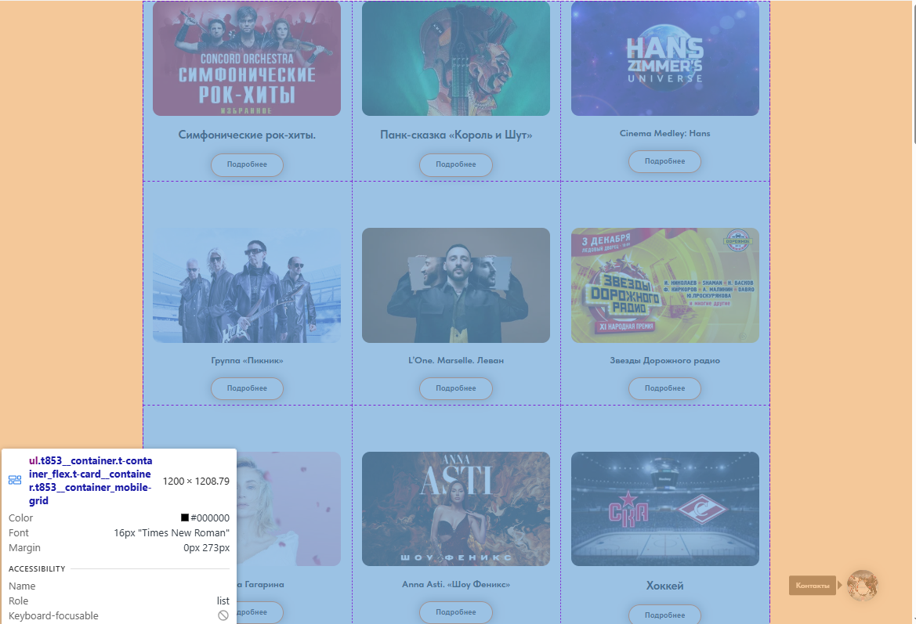
Контейнер отдельного мероприятия:
<div class="t-card__col
" style="cursor: pointer;"> <div class="t853__content"> <div class="t853__imgwrapper
" style="padding-bottom:61.111111111111%;" bgimgfield="li_img__1646935827275"> <div class="t853__bgimg t-bgimg loaded" data-original="https://static.tildacdn.com/tild3838-6361-4539-a663-373361386264/d3c6cb7a08dde477bfed.jpg" style="background-image: url(&quot;https://optim.tildacdn.com/tild3838-6361-4539-a663-373361386264/-/cover/360x220/center/center/-/format/webp/d3c6cb7a08dde477bfed.jpg.webp&quot;);" role="img" aria-label="Симфонические рок-хиты." itemscope="" itemtype="http://schema.org/ImageObject"> <meta itemprop="image" content="https://static.tildacdn.com/tild3838-6361-4539-a663-373361386264/d3c6cb7a08dde477bfed.jpg"> <meta itemprop="caption" content="Симфонические рок-хиты."> </div> </div> <div class="t853__textwrapper"> <div class="t-card__descr t-descr t-descr_sm" field="li_descr__1646935827275"> <div style="font-size: 22px;" data-customstyle="yes"><strong>Симфонические рок-хиты.</strong></div> </div> </div> </div> <div class="t-card__btn-wrapper"> <a class="t-btn t-btnflex t-btnflex_type_button t-btnflex_sm t-card__btn t-card__link" href="https://teatr-art.ru/ledovii" id="cardbtn1_824337954" data-lid="1646935827275"> <span class="t-btnflex__text">Подробнее</span> <style>#rec824337954 .t-btnflex.t-btnflex_type_button {color:#120c0c;border-style:solid !important;border-color:#ff6600 !important;--border-width:2px;border-radius:30px;box-shadow:0px 0px 20px rgba(0,0,0,0.4) !important;font-family:Arial;transition-duration:0.2s;transition-property:background-color,color,border-color,box-shadow,opacity,transform;transition-timing-function:ease-in-out;}@media (hover:hover) {#rec824337954 .t-btnflex.t-btnflex_type_button:not(.t-animate_no-hover):hover {background-color:#ff6600 !important;}#rec824337954 .t-btnflex.t-btnflex_type_button:not(.t-animate_no-hover):focus-visible {background-color:#ff6600 !important;}}</style> </a> </div> </div>
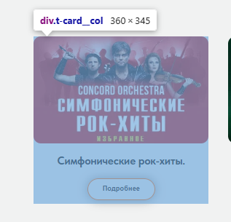
Html элементы, содержащие: Название, дату, время, описание
Название мероприятия:
<strong>Симфонические рок-хиты.</strong>
дату, время, описание находится на отдельной странице в яндекс афише.
Вот ссылка на нее:
<a class="t-btn t-btnflex t-btnflex_type_button t-btnflex_sm t-card__btn t-card__link" href="https://teatr-art.ru/ledovii" id="cardbtn1_824337954" data-lid="1646935827275"> <span class="t-btnflex__text">Подробнее</span> <style>#rec824337954 .t-btnflex.t-btnflex_type_button {color:#120c0c;border-style:solid !important;border-color:#ff6600 !important;--border-width:2px;border-radius:30px;box-shadow:0px 0px 20px rgba(0,0,0,0.4) !important;font-family:Arial;transition-duration:0.2s;transition-property:background-color,color,border-color,box-shadow,opacity,transform;transition-timing-function:ease-in-out;}@media (hover:hover) {#rec824337954 .t-btnflex.t-btnflex_type_button:not(.t-animate_no-hover):hover {background-color:#ff6600 !important;}#rec824337954 .t-btnflex.t-btnflex_type_button:not(.t-animate_no-hover):focus-visible {background-color:#ff6600 !important;}}</style> </a>
Пагинация отсутствует
Нет на основном сайте детальной информации про мероприятие

